-- Select all customers from USA and older 25 years old
SELECT
first_name,
last_name,
age,
country
FROM
Customers
WHERE
country = 'USA' AND age > 25;
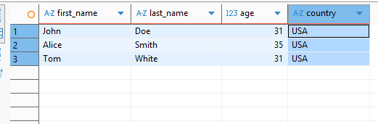

-- Select orders where amount > 1000
SELECT
order_id,
item,
amount,
customer_id
FROM
Orders
WHERE
amount > 1000;
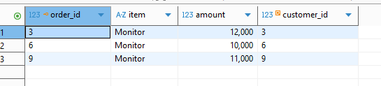

-- Select orders with name of customer
SELECT
c.first_name,
c.last_name ,
o.item,
o.amount
FROM
Orders AS o
INNER JOIN Customers AS c
ON o.customer_id = c.customer_id;
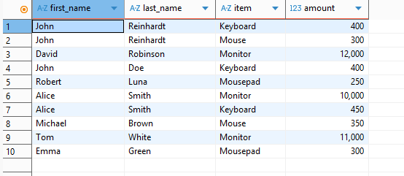

-- Select status of deliveries with name of customer
SELECT
s.status,
c.first_name,
c.last_name
FROM
Shippings AS s
INNER JOIN Customers AS c
ON s.customer = c.customer_id;
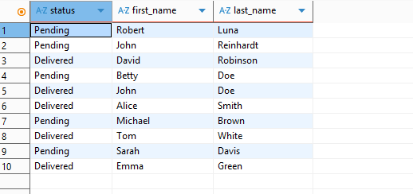

-- Select number of customers by country
SELECT
country,
count(*) AS number_of_customers
FROM
Customers
GROUP BY country;
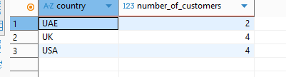

-- Select number of orders and average amount for item
SELECT
item,
count(*) AS number_of_orders,
avg(amount) AS average_amount
FROM
Orders
GROUP BY item;
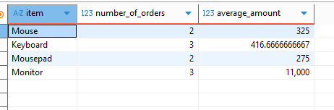

-- Select customers sorted by age descended
SELECT
first_name,
age
FROM
Customers
ORDER BY age DESC;
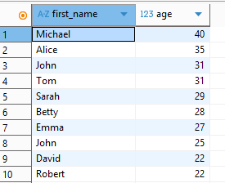

-- Select customers with max orders amount
SELECT
c.first_name,
c.last_name ,
o.amount AS max_amount
FROM Customers AS c
INNER JOIN Orders AS o
ON c.customer_id = o.customer_id
WHERE o.amount = (
SELECT max(amount) FROM Orders
);
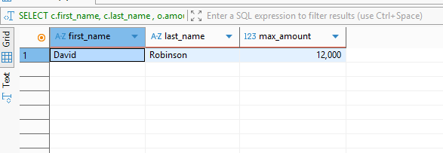

-- Select total amount of orders for each customer
SELECT
customer_id,
order_id,
item,
amount,
sum(amount) OVER (PARTITION BY customer_id) AS total_by_customer
FROM
Orders;
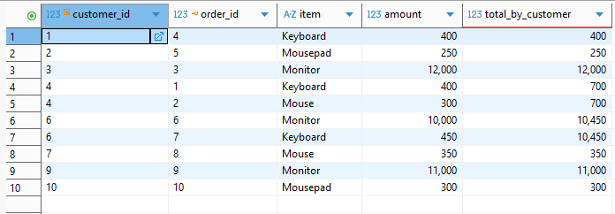

-- Select customers with at least 2 orders and delivery status = 'Delivered'
SELECT
CONCAT(c.first_name, ' ', c.last_name) AS full_name,
c.country,
COUNT(o.order_id) AS total_orders,
SUM(o.amount) AS total_amount
FROM Customers AS c
INNER JOIN Shippings AS s
ON c.customer_id = s.customer
INNER JOIN Orders AS o
ON c.customer_id = o.customer_id
WHERE s.status = 'Delivered'
GROUP BY c.customer_id
HAVING COUNT(o.order_id) > 1;